**PREDICTING FLIGHT DELAYS WITH ERROR CALCULATION USING MACHINE LEARNED CLASSIFIERS**

**ABSTRACT**

Flight delay is a major problem in the aviation sector. During the last two decades, the growth of the aviation sector has caused air traffic congestion, which has caused flight delays. Flight delays result not only in the loss of fortune also negatively impact the environment. Flight delays also cause significant losses for airlines operating commercial flights. Therefore, they do everything possible in the prevention or avoidance of delays and cancellations of flights by taking some measures. In this paper, using machine learning models such as Logistic Regression, Decision Tree Regression, Bayesian Ridge, Random Forest Regression and Gradient Boosting Regression we predict whether the arrival of a particular flight will be delayed or not.

**CHAPTER-1**

**INTRODUCTION**

Statistical modelling is a mathematical way of making approximations from input data. These approximations are then used to make predictions. Statistical models help in predicting the future probabilistic behavior of a system based on past statistical data. Predictive modelling has been used in many fields, for example in crime cases to detect the likeliness of an email being spam and flight delays. In evaluation of how different models perform in modelling of flight delays, regression models have been found efficient in predicting flight delays since they highlighted the various causes of flight delays . However, they could not categorize complex data. Econometric models have been used to model scheduled flight cancellation and to show how delays from one airport were propagated to other destinations. These models did not provide a complete vindication since they ignored variables that were difficult to quantify. When subjected to social-economic situations, the models showed discriminative and subjective results. Among the models used, random forest has been found to have superior performance. Prediction accuracy may vary due to factors such as time of forecast and airline dynamics. A developed multiple regression model has shown that distance, day and scheduled departure are key factors in predicting flight delay. However, though the model gives flagged out the significant factors, its prediction accuracy was poor. Moreover, the model is limited to only one flight route. Comparison of other models, such as the K-means clustering Algorithms and Fourier fit model, have shown that Fourier fit model could predict flight delays with a high precision. However, the two models were found to be suitable a single airport, but not prediction applied to multiple airports. Probability models such as the normal distribution and the Poisson distribution have been used to Model flight departure and arrival delays. However, the prediction accuracy varied depending on variables such as time duration and the number of airports considered. Normal distribution was observed to model flight departure delays better while arrival delays were modelled better by the Poisson distribution. However, these models are parametric and assume that the response takes a particular functional form. If this form is not met by the training data set, the resulting model will not fit the data well and the estimates from this model will be poor. Logistic regression model has been used to model flight on-time performance. The model showed good performance with the training data set and the testing data set. The variance of the model was also low. However, its parametric nature can be a weakness if the training data set will not meet the assumed functional form. Neural networks performed better than logistic regression model in prediction of death in patients with suspected sepsis in an emergency room. This was attributed to the neural networks having few features to be verified before model construction and its ability to fit non-linear relationship between dependent and independent variables. Support Vector Machine (SVM) model was fitted and it was observed to fit allc the training data set correctly. In prediction of auto-ignition temperatures of organic compounds, SVM perfomed better than multiple linear regression and back propagation neural network. Random forests have been used to model delay innovation. Results from this study showed that more decision trees were better but up to a certain critical value. Prediction of new vehicle prediction approach in computational toxicology led to results with random forest performing better than decision tree.

Random forests and SVM are classified under machine learning. Under machine learning, the training data is divided into several samples. At each sample, a model is fitted and tested against the testing data set. The sample that yields the best model is obtained from a plot of the train errors and the test errors against the sample size. Their overall advantage of the SVM and the random forest is their non-parametric nature in that they do not assume a particular functional form of the response under investigation. This makes them very flexible since they fit a wider range of shapes of the response. Modelling studies on flight delays are not available for Kenya aviation industry. The aim of this study is to compare the prediction power of models that have been used to predict flight delays at Jomo Kenyatta International Airport. Secondary data that was obtained from Kenya Airports Authority on flights at Jomo Kenyatta International Airport. The data was for the year 2017/2018 where the year started on March 2017 and ended on March 2018. The variables used included; the day of the flight (that is, Monday to Sunday), the month (that is, January to December), the airline, the flight class (that is, domestic or international), season (that is, summer (March to October) or winter (October to March), capacity of the aircraft, flight ID (tail number) and whether the flight had flown at night or during the day. The data was analysed using R-Score statistical software. The time difference between the scheduled time and the actual time for flights was calculated. A time difference of more than 15 minutes was classified as a delay and it was given a value 1 and a time difference of less than 15 minutes was classified a non-delay and given the value 0. The three models, logistic regression model, SVM model and Random Forest, were fitted by machine learning. The entire data set was divided into a training data set of 15000 flights and a testing data set of 5000 flights. In fitting the models, different random samples were created from the training data by the programmed laptop used. For each sample, a model was fitted and tested using the testing data.

**CHAPTER-2**

**LITERATURE SURVEY**

## 1) Capacity And Delay Analysis For Airport Manoeuvring Areas Using Simulation

**AUTHORS: E. Cinar, F. Aybek, A. Caycar, C. Cetek**

To investigate the air traffic flow in a highly complex system such as an airport manoeuvring area, a two-stage method based on fast- and real-time simulation techniques is applied. The first stage involves the analysis with fast- and real-time simulations of a baseline model created to determine the congestion points. Based on the analysis, improvements to be performed in the layout of the manoeuvring area are proposed. In the second stage, alternative scenarios implementing these improvements are generated and evaluated in a fast-time simulation environment. Based on the results of simulations of different runway configurations, the main areas of congestion in the baseline airport model are determined. Congestion nodes are identified in the departure queue points and in the taxiway system. To mitigate congestion at these points, three alternative models comprising taxiway and fast-exit taxiway reconfigurations are tested using the fast-time simulation technique. The alternative solution found to be the best in these tests is selected for further testing in real-time simulations. It is shown that the solution would result in an increase in the number of hourly operations and a significant decrease in total ground delays. When conducting the studies needed to identify congestion and design improvements, simulation techniques save both expense and time. Although fast-time simulations are usually adequate for identifying solutions, when critical configurations for the airport are considered, it is shown that it is necessary to also test the results of the fast-time simulations in real-time simulations. The effects of meteorological events, such as rain, fog and snow, etc. are ignored in the simulations. Ground movements in manoeuvring areas are significantly affected by the runways used. Consequently, to enable a comprehensive evaluation in the study, three alternative runway use scenarios are examined. This study utilizes a combination of fast- and real-time simulation techniques to identify the points where congestion occurs in the manoeuvring areas of large-scale airports and to find solutions to minimize the congestion. This approach attempts to combine advantages of both techniques while reducing their shortcomings. No study is found in the literature using both of these techniques together for the capacity analysis of airport manoeuvring areas.

# 2) Flight Arrival Delay Prediction Using Gradient Boosting Classifier

**AUTHORS:**  **Navoneel, et al., Chakrabarty**

The basic objective of the proposed work is to analyse arrival delay of the flights using data mining and four supervised machine learning algorithms: random forest, Support Vector Machine (SVM), Gradient Boosting Classifier (GBC) and k-nearest neighbour algorithm, and compare their performances to obtain the best performing classifier. To train each predictive model, data has been collected from BTS, United States Department of Transportation. The data included all the flights operated by American Airlines, connecting the top five busiest airports of United States, located in Atlanta, Los Angeles, Chicago, Dallas/Fort Worth, and New York, in the years 2015 and 2016. Aforesaid supervised machine learning algorithms were evaluated to predict the arrival delay of individual scheduled flights. All the algorithms were used to build the predictive models and compared to each other to accurately find out whether a given flight will be delayed more than 15 min or not. The result is that the gradient boosting classifier gives the best predictive arrival delay performance of 79.7% of total scheduled American Airlines’ flights in comparison to kNN, SVM and random forest. Such a predictive model based on the GBC potentially can save huge losses; the commercial airlines suffer due to arrival delays of their scheduled flights.

# 3) Prediction Of Weatherinduced Airline Delays Based On Machine Learning Algorithms

**AUTHORS** **: Y. J. Kim, S. Briceno, D. Mavris, Sun Choi**

# The primary goal of the model proposed in this paper is to predict airline delays caused by inclement weather conditions using data mining and supervised machine learning algorithms. US domestic flight data and the weather data from 2005 to 2015 were extracted and used to train the model. To overcome the effects of imbalanced training data, sampling techniques are applied. Decision trees, random forest, the AdaBoost and the k-Nearest-Neighbors were implemented to build models which can predict delays of individual flights. Then, each of the algorithms' prediction accuracy and the receiver operating characteristic (ROC) curve were compared. In the prediction step, flight schedule and weather forecast were gathered and fed into the model. Using those data, the trained model performed a binary classification to predicted whether a scheduled flight will be delayed or on-time.

# 4) Flight Delay Prediction System Using Weighted Multiple Linear Regression

**AUTHORS** : **S. Sharma, H. Sangoi, R. Raut, V. C. Kotak, S. Oza**

Flight delays hurt airlines, airports, and passengers. Their prediction is crucial during the decision-making process for all players of commercial aviation. Moreover, the development of accurate prediction models for flight delays became cumbersome due to the complexity of air transportation system, the number of methods for prediction, and the deluge of flight data. In this context, this paper presents a thorough literature review of approaches used to build flight delay prediction models from the Data Science perspective. We propose a taxonomy and summarize the initiatives used to address the flight delay prediction problem, according to scope, data, and computational methods, giving particular attention to an increased usage of machine learning methods. Besides, we also present a timeline of significant works that depicts relationships between flight delay prediction problems and research trends to address them.

**5)** **Development Of A Predictive Model For On-Time Arrival Fight Of Airliner By Discovering Correlation Between Fight And Weather Data**

**AUTHORS**: Noriko, Etani

An important business of airlines is to get customer satisfaction. Due to bad weather, a mechanical reason, and the late arrival of the aircraft to the point of departure, flights delay and lead to customer dissatisfaction. A predictive model of on-time arrival flight is proposed with using flight data and weather data. The key research in this paper is to discover the correlation between flight data and weather data. The relation between pressure pattern and flight data of Peach Aviation, which is LCC (low-cost carrier) in Japan, are clarified, and it is found that the sea-level pressures of 3 weather observation spots, which are Wakkanai as the most northern spot, Minami-Torishima as the most eastern spot, and Yonagunijima as the most western spot, can classify the pressure patterns. As a result, on-time arrival fight is predicted at 77% of the accuracy with using Random Forest Classifier of machine learning. Furthermore, feasibility of the predictive model is evaluated by developing a tool of on-time arrival flight prediction.

**CHAPTER-3**

**SYSTEM ANALYSIS & DESIGN**

**EXISTING SYSTEM:**

Supervised automatic learning algorithms Support Vector Machine and the k-nearest neighbor to predict delays in the arrival of operated flights including the five busiest US airports. The precision achieved was very low with gradient booster as a classifier with a limited data set. Applied machine learning algorithms k-Nearest Neighbors to predict delays on individual flights. Flight schedule data and weather forecasts have been incorporated into the model. Sampling techniques were used to balance the data and it was observed that the accuracy of the classifier trained without sampling was more that of the trained classifier with sampling techniques.

**DISADVANTAGES OF EXISTING SYSTEM:**

* Non-parametric nature do not assume a particular functional form of the response under investigation data.
* The predictability may additionally range because of factors such as the number of origin destination pairs and the forecast horizon.
* The forecasts were based on some key attributes.
* **Algorithm**: Multiple Linear Regression, Support Vector Machine, k-nearest neighbor.

**PROPOSED SYSTEM:**

To predict flight delays to train models, we have collected data accumulated by the Bureau of Transportation, U.S. Statistics of all the domestic flights taken in 2015 was used. The US Bureau of Transport Statistics provides statistics of arrival and departure that includes actual departure time, scheduled departure time, and scheduled elapsed time, wheels-off time, departure delay and taxi-out time per airport. Cancellation and Rerouting by the airport and the airline with the date and time and flight labelling along with airline airborne time are also provided. The data set consists of 31 columns and 20277 and it can grow able by our implementation. By using pandas library we can fill the missing values which is essential for processing data for model.

**ADVANTAGES OF PROPOSED SYSTEM:**

* Supervised learning technique to gather the advantages of having the schedule and real arrival time.
* Algorithms are light computation cost will taken.
* We develop a system that predicts for a delay in flight departure based on certain parameters.

**Algorithm**: Logistic Regression, Decision Tree Regressor, Bayesian Ridge, Random Forest Regressor, Gradient Boosting Regressor

**SYSTEM DESIGN**

**SYSTEM ARCHITECTURE:**

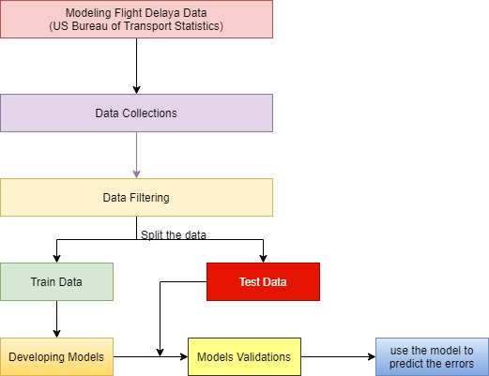

**DATA FLOW DIAGRAM:**

1. The DFD is also called as bubble chart. It is a simple graphical formalism that can be used to represent a system in terms of input data to the system, various processing carried out on this data, and the output data is generated by this system.
2. The data flow diagram (DFD) is one of the most important modeling tools. It is used to model the system components. These components are the system process, the data used by the process, an external entity that interacts with the system and the information flows in the system.
3. DFD shows how the information moves through the system and how it is modified by a series of transformations. It is a graphical technique that depicts information flow and the transformations that are applied as data moves from input to output.
4. DFD is also known as bubble chart. A DFD may be used to represent a system at any level of abstraction. DFD may be partitioned into levels that represent increasing information flow and functional detail.

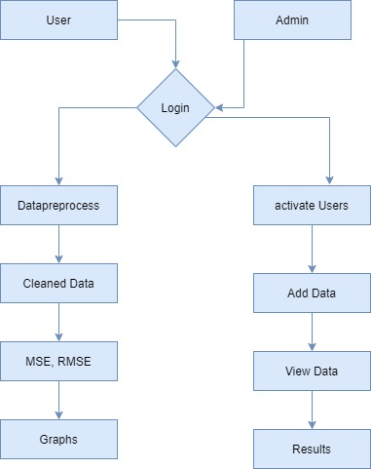

**UML DIAGRAMS**

UML stands for Unified Modeling Language. UML is a standardized general-purpose modeling language in the field of object-oriented software engineering. The standard is managed, and was created by, the Object Management Group.

The goal is for UML to become a common language for creating models of object oriented computer software. In its current form UML is comprised of two major components: a Meta-model and a notation. In the future, some form of method or process may also be added to; or associated with, UML.

The Unified Modeling Language is a standard language for specifying, Visualization, Constructing and documenting the artifacts of software system, as well as for business modeling and other non-software systems.

The UML represents a collection of best engineering practices that have proven successful in the modeling of large and complex systems.

The UML is a very important part of developing objects oriented software and the software development process. The UML uses mostly graphical notations to express the design of software projects.

**GOALS:**

The Primary goals in the design of the UML are as follows:

1. Provide users a ready-to-use, expressive visual modeling Language so that they can develop and exchange meaningful models.
2. Provide extendibility and specialization mechanisms to extend the core concepts.
3. Be independent of particular programming languages and development process.
4. Provide a formal basis for understanding the modeling language.
5. Encourage the growth of OO tools market.
6. Support higher level development concepts such as collaborations, frameworks, patterns and components.
7. Integrate best practices.

**USE CASE DIAGRAM:**

A use case diagram in the Unified Modeling Language (UML) is a type of behavioral diagram defined by and created from a Use-case analysis. Its purpose is to present a graphical overview of the functionality provided by a system in terms of actors, their goals (represented as use cases), and any dependencies between those use cases. The main purpose of a use case diagram is to show what system functions are performed for which actor. Roles of the actors in the system can be depicted. 

**CLASS DIAGRAM:**

In software engineering, a class diagram in the Unified Modeling Language (UML) is a type of static structure diagram that describes the structure of a system by showing the system's classes, their attributes, operations (or methods), and the relationships among the classes. It explains which class contains information.



**SEQUENCE DIAGRAM:**

A sequence diagram in Unified Modeling Language (UML) is a kind of interaction diagram that shows how processes operate with one another and in what order. It is a construct of a Message Sequence Chart. Sequence diagrams are sometimes called event diagrams, event scenarios, and timing diagrams.



**ACTIVITY DIAGRAM:**

Activity diagrams are graphical representations of workflows of stepwise activities and actions with support for choice, iteration and concurrency. In the Unified Modeling Language, activity diagrams can be used to describe the business and operational step-by-step workflows of components in a system. An activity diagram shows the overall flow of control.



**INPUT AND OUTPUT DESIGN**

**INPUT DESIGN**

The input design is the link between the information system and the user. It comprises the developing specification and procedures for data preparation and those steps are necessary to put transaction data in to a usable form for processing can be achieved by inspecting the computer to read data from a written or printed document or it can occur by having people keying the data directly into the system. The design of input focuses on controlling the amount of input required, controlling the errors, avoiding delay, avoiding extra steps and keeping the process simple. The input is designed in such a way so that it provides security and ease of use with retaining the privacy. Input Design considered the following things:

* What data should be given as input?
* How the data should be arranged or coded?
* The dialog to guide the operating personnel in providing input.
* Methods for preparing input validations and steps to follow when error occur.

**OBJECTIVES**

1.Input Design is the process of converting a user-oriented description of the input into a computer-based system. This design is important to avoid errors in the data input process and show the correct direction to the management for getting correct information from the computerized system.

2. It is achieved by creating user-friendly screens for the data entry to handle large volume of data. The goal of designing input is to make data entry easier and to be free from errors. The data entry screen is designed in such a way that all the data manipulates can be performed. It also provides record viewing facilities.

3.When the data is entered it will check for its validity. Data can be entered with the help of screens. Appropriate messages are provided as when needed so that the user will not be in maize of instant. Thus the objective of input design is to create an input layout that is easy to follow

**OUTPUT DESIGN**

A quality output is one, which meets the requirements of the end user and presents the information clearly. In any system results of processing are communicated to the users and to other system through outputs. In output design it is determined how the information is to be displaced for immediate need and also the hard copy output. It is the most important and direct source information to the user. Efficient and intelligent output design improves the system’s relationship to help user decision-making.

1. Designing computer output should proceed in an organized, well thought out manner; the right output must be developed while ensuring that each output element is designed so that people will find the system can use easily and effectively. When analysis design computer output, they should Identify the specific output that is needed to meet the requirements.

2.Select methods for presenting information.

3.Create document, report, or other formats that contain information produced by the system.

The output form of an information system should accomplish one or more of the following objectives.

* Convey information about past activities, current status or projections of the
* Future.
* Signal important events, opportunities, problems, or warnings.
* Trigger an action.
* Confirm an action.

**SYSTEM SPECIFICATION:**

**HARDWARE REQUIREMENTS:**

* **System :** Intel i3
* **Hard Disk :** 1 TB.
* **Monitor** : 14’ Colour Monitor.
* **Mouse :** Optical Mouse.
* **Ram :** 4GB.

**SOFTWARE REQUIREMENTS:**

* **Operating system :** Windows 10.
* **Coding Language :** Python.
* **Front-End :** Html. CSS
* **Designing :** Html,css,javascript.
* **Data Base :** SQLite.

**CHAPTER-4**

**SOFTWARE ENVIRONMENT**

Python is a general-purpose interpreted, interactive, object-oriented, and high-level programming language. An [interpreted language](https://en.wikipedia.org/wiki/Interpreted_language), Python has a design philosophy that emphasizes code [readability](https://en.wikipedia.org/wiki/Readability) (notably using [whitespace](https://en.wikipedia.org/wiki/Whitespace_character) indentation to delimit [code blocks](https://en.wikipedia.org/wiki/Code_block) rather than curly brackets or keywords), and a syntax that allows programmers to express concepts in fewer [lines of code](https://en.wikipedia.org/wiki/Source_lines_of_code) than might be used in languages such as [C++](https://en.wikipedia.org/wiki/C%2B%2B)or [Java](https://en.wikipedia.org/wiki/Java_(programming_language)). It provides constructs that enable clear programming on both small and large scales. Python interpreters are available for many [operating systems](https://en.wikipedia.org/wiki/Operating_system). [C Python](https://en.wikipedia.org/wiki/CPython), the [reference implementation](https://en.wikipedia.org/wiki/Reference_implementation) of Python, is [open source](https://en.wikipedia.org/wiki/Open_source) software and has a community-based development model, as do nearly all of its variant implementations. CPython is managed by the non-profit [Python Software Foundation](https://en.wikipedia.org/wiki/Python_Software_Foundation). Python features a [dynamic type](https://en.wikipedia.org/wiki/Dynamic_type) system and automatic [memory management](https://en.wikipedia.org/wiki/Memory_management). It supports multiple [programming paradigms](https://en.wikipedia.org/wiki/Programming_paradigm), including [object-oriented](https://en.wikipedia.org/wiki/Object-oriented_programming), [imperative](https://en.wikipedia.org/wiki/Imperative_programming), [functional](https://en.wikipedia.org/wiki/Functional_programming) and [procedural](https://en.wikipedia.org/wiki/Procedural_programming), and has a large and comprehensive [standard library](https://en.wikipedia.org/wiki/Standard_library).

**Python Identifiers**

A Python identifier is a name used to identify a variable, function, class, module or other object. An identifier starts with a letter A to Z or a to z or an underscore (_) followed by zero or more letters, underscores and digits (0 to 9).

Python does not allow punctuation characters such as @, $, and % within identifiers. Python is a case sensitive programming language. Thus, Manpower and manpower are two different identifiers in Python.

Here are naming conventions for Python identifiers −

Class names start with an uppercase letter. All other identifiers start with a lowercase letter.

Starting an identifier with a single leading underscore indicates that the identifier is private.

Starting an identifier with two leading underscores indicates a strongly private identifier.

If the identifier also ends with two trailing underscores, the identifier is a language-defined special name.

**DJANGO**

Django is a high-level Python Web framework that encourages rapid development and clean, pragmatic design. Built by experienced developers, it takes care of much of the hassle of Web development, so you can focus on writing your app without needing to reinvent the wheel. It’s free and open source.

Django's primary goal is to ease the creation of complex, database-driven websites. Django emphasizes [reusability](https://en.wikipedia.org/wiki/Reusability" \o "Reusability)and "pluggability" of components, rapid development, and the principle of [don't repeat yourself](https://en.wikipedia.org/wiki/Don%27t_repeat_yourself). Python is used throughout, even for settings files and data models.

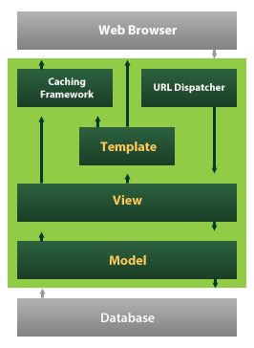

Django also provides an optional administrative [create, read, update and delete](https://en.wikipedia.org/wiki/Create,_read,_update_and_delete) interface that is generated dynamically through [introspection](https://en.wikipedia.org/wiki/Introspection_(computer_science)) and configured via admin models

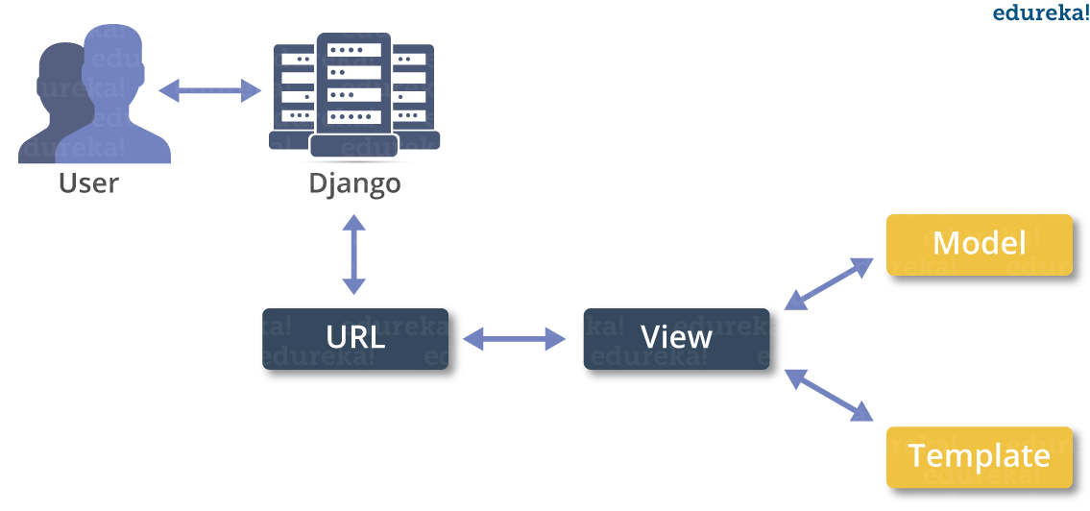

**Create a Project**

Whether you are on Windows or Linux, just get a terminal or a cmd prompt and navigate to the place you want your project to be created, then use this code −

$ django-admin startproject myproject

This will create a "myproject" folder with the following structure −

myproject/

manage.py

myproject/

__init__.py

settings.py

urls.py

wsgi.py

The Project Structure

The “myproject” folder is just your project container, it actually contains two elements −

manage.py − This file is kind of your project local django-admin for interacting with your project via command line (start the development server, sync db...). To get a full list of command accessible via manage.py you can use the code −

$ python manage.py help

The “myproject” subfolder − This folder is the actual python package of your project. It contains four files −

__init__.py − Just for python, treat this folder as package.

settings.py − As the name indicates, your project settings.

urls.py − All links of your project and the function to call. A kind of ToC of your project.

wsgi.py − If you need to deploy your project over WSGI.

Setting Up Your Project

Your project is set up in the subfolder myproject/settings.py. Following are some important options you might need to set −

DEBUG = True

This option lets you set if your project is in debug mode or not. Debug mode lets you get more information about your project's error. Never set it to ‘True’ for a live project. However, this has to be set to ‘True’ if you want the Django light server to serve static files. Do it only in the development mode.

**Introduction to Python**

Python is an interpreted, high-level, general-purpose programming language. Created by Guido van Rossum and first released in 1991, Python's design philosophy emphasizes code readability with its notable use of significant whitespace. Its language constructs and object-oriented approach aim to help programmers write clear, logical code for small and large-scale projects. Python is dynamically typed and garbage-collected. It supports multiple programming paradigms, including structured (particularly, procedural), object-oriented, and functional programming. Python is often described as a "batteries included" language due to its comprehensive standard library. Python was conceived in the late 1980s as a successor to the ABC language. Python 2.0, released in 2000, introduced features like list comprehensions and a garbage collection system capable of collecting reference cycles. Python 3.0, released in 2008, was a major revision of the language that is not completely backward-compatible, and much Python 2 code does not run unmodified on Python 3. The Python 2 language, i.e. Python 2.7.x, was officially discontinued on 1 January 2020 (first planned for 2015) after which security patches and other improvements will not be released for it.[32][33] With Python 2's end-of-life, only Python 3.5.x and later are supported. Python interpreters are available for many operating systems. A global community of programmers develops and maintains CPython, an open source[35] reference implementation. A non-profit organization, the Python Software Foundation, manages and directs resources for Python and CPython development.

**SYNTAX AND SEMANTICS**

Python is meant to be an easily readable language. Its formatting is visually uncluttered, and it often uses English keywords where other languages use punctuation.

Unlike many other languages, it does not use curly brackets to delimit blocks, and semicolons after statements are optional. It has fewer syntactic exceptions and special cases than C or Pascal.

**Indentation**

Main article: Python syntax and semantics § Indentation

Python uses whitespace indentation, rather than curly brackets or keywords, to delimit blocks. An increase in indentation comes after certain statements; a decrease in indentation signifies the end of the current block. Thus, the program's visual structure accurately represents the program's semantic structure. This feature is sometimes termed the off-side rule, which some other languages share, but in most languages indentation doesn't have any semantic meaning.

**Statements and control flow**

Python's statements include (among others):

The assignment statement (token '=', the equals sign). This operates differently than in traditional imperative programming languages, and this fundamental mechanism (including the nature of Python's version of variables) illuminates many other features of the language. Assignment in C, e.g., x = 2, translates to "typed variable name x receives a copy of numeric value 2". The (right-hand) value is copied into an allocated storage location for which the (left-hand) variable name is the symbolic address. The memory allocated to the variable is large enough (potentially quite large) for the declared type. In the simplest case of Python assignment, using the same example, x = 2, translates to "(generic) name x receives a reference to a separate, dynamically allocated object of numeric (int) type of value 2." This is termed binding the name to the object. Since the name's storage location doesn't contain the indicated value, it is improper to call it a variable. Names may be subsequently rebound at any time to objects of greatly varying types, including strings, procedures, complex objects with data and methods, etc. Successive assignments of a common value to multiple names, e.g., x = 2; y = 2; z = 2 result in allocating storage to (at most) three names and one numeric object, to which all three names are bound.

Since a name is a generic reference holder it is unreasonable to associate a fixed data type with it. However at a given time a name will be bound to some object, which will have a type; thus there is dynamic typing.

* The if statement, which conditionally executes a block of code, along with else and elif (a contraction of else-if).
* The for statement, which iterates over an iterable object, capturing each element to a local variable for use by the attached block.
* The while statement, which executes a block of code as long as its condition is true.
* The try statement, which allows exceptions raised in its attached code block to be caught and handled by except clauses; it also ensures that clean-up code in a finally block will always be run regardless of how the block exits.
* The raise statement, used to raise a specified exception or re-raise a caught exception.
* The class statement, which executes a block of code and attaches its local namespace to a class, for use in object-oriented programming.
* The def statement, which defines a function or method.
* The with statement, from Python 2.5 released in September 2006, which encloses a code block within a context manager (for example, acquiring a lock before the block of code is run and releasing the lock afterwards, or opening a file and then closing it), allowing Resource Acquisition Is Initialization (RAII)-like behavior and replaces a common try/finally idiom.
* The break statement, exits from the loop.
* The continue statement, skips this iteration and continues with the next item.
* The pass statement, which serves as a NOP. It is syntactically needed to create an empty code block.
* The assert statement, used during debugging to check for conditions that ought to apply.
* The yield statement, which returns a value from a generator function. From Python 2.5, yield is also an operator. This form is used to implement coroutines.

The import statement, which is used to import modules whose functions or variables can be used in the current program. There are three ways of using import: import <module name> [as <alias>] or from <module name> import * or from <module name> import <definition 1> [as <alias 1>], <definition 2> [as <alias 2>],

The print statement was changed to the print() function in Python 3.

Python does not support tail call optimization or first-class continuations, and, according to Guido van Rossum, it never will. However, better support for coroutine-like functionality is provided in 2.5, by extending Python's generators. Before 2.5, generators were lazy iterators; information was passed unidirectionally out of the generator. From Python 2.5, it is possible to pass information back into a generator function, and from Python 3.3, the information can be passed through multiple stack levels.

**EXPRESSIONS**

Some Python expressions are similar to languages such as C and Java, while some are not:

Addition, subtraction, and multiplication are the same, but the behavior of division differs. There are two types of divisions in Python. They are floor division (or integer division) // and floating point/division. Python also added the ** operator for exponentiation.

From Python 3.5, the new @ infix operator was introduced. It is intended to be used by libraries such as NumPy for matrix multiplication.

From Python 3.8, the syntax :=, called the 'walrus operator' was introduced. It assigns values to variables as part of a larger expression.

In Python, == compares by value, versus Java, which compares numerics by value and objects by reference. (Value comparisons in Java on objects can be performed with the equals() method.) Python's is operator may be used to compare object identities (comparison by reference). In Python, comparisons may be chained, for example a <= b <= c.

Python uses the words and, or, not for its boolean operators rather than the symbolic &&, ||, ! used in Java and C.

Python has a type of expression termed a list comprehension. Python 2.4 extended list comprehensions into a more general expression termed a generator expression.

Anonymous functions are implemented using lambda expressions; however, these are limited in that the body can only be one expression.

Conditional expressions in Python are written as x if c else y (different in order of operands from the c ? x : y operator common to many other languages).

Python makes a distinction between lists and tuples. Lists are written as [1, 2, 3], are mutable, and cannot be used as the keys of dictionaries (dictionary keys must be immutable in Python). Tuples are written as (1, 2, 3), are immutable and thus can be used as the keys of dictionaries, provided all elements of the tuple are immutable. The + operator can be used to concatenate two tuples, which does not directly modify their contents, but rather produces a new tuple containing the elements of both provided tuples. Thus, given the variable t initially equal to (1, 2, 3), executing t = t + (4, 5) first evaluates t + (4, 5), which yields (1, 2, 3, 4, 5), which is then assigned back to t, thereby effectively "modifying the contents" of t, while conforming to the immutable nature of tuple objects. Parentheses are optional for tuples in unambiguous contexts.

Python features sequence unpacking wherein multiple expressions, each evaluating to anything that can be assigned to (a variable, a writable property, etc.), are associated in the identical manner to that forming tuple literals and, as a whole, are put on the left hand side of the equal sign in an assignment statement. The statement expects an iterable object on the right hand side of the equal sign that produces the same number of values as the provided writable expressions when iterated through, and will iterate through it, assigning each of the produced values to the corresponding expression on the left.

Python has a "string format" operator %. This functions analogous to printf format strings in C, e.g. "spam=%s eggs=%d" % ("blah", 2) evaluates to "spam=blah eggs=2".

In Python 3 and 2.6+, this was supplemented by the format() method of the str class, e.g. "spam={0} eggs={1}".format("blah", 2). Python 3.6 added "f-strings": blah = "blah"; eggs = 2; f'spam={blah} eggs={eggs}'.

**Python has various kinds of string literals:**

Strings delimited by single or double quote marks. Unlike in Unix shells, Perl and Perl-influenced languages, single quote marks and double quote marks function identically. Both kinds of string use the backslash (\) as an escape character. String interpolation became available in Python 3.6 as "formatted string literals".

Triple-quoted strings, which begin and end with a series of three single or double quote marks. They may span multiple lines and function like here documents in shells, Perl and Ruby.

Raw string varieties, denoted by prefixing the string literal with an r. Escape sequences are not interpreted; hence raw strings are useful where literal backslashes are common, such as regular expressions and Windows-style paths. Compare "@-quoting" in C#.

Python has array index and array slicing expressions on lists, denoted as a[key], a[start:stop] or a[start:stop:step]. Indexes are zero-based, and negative indexes are relative to the end. Slices take elements from the start index up to, but not including, the stop index. The third slice parameter, called step or stride, allows elements to be skipped and reversed. Slice indexes may be omitted, for example a[:] returns a copy of the entire list. Each element of a slice is a shallow copy.

In Python, a distinction between expressions and statements is rigidly enforced, in contrast to languages such as Common Lisp, Scheme, or Ruby. This leads to duplicating some functionality. For example:

List comprehensions vs. for-loops

Conditional expressions vs. if blocks

The eval() vs. exec() built-in functions (in Python 2, exec is a statement); the former is for expressions, the latter is for statements.

Statements cannot be a part of an expression, so list and other comprehensions or lambda expressions, all being expressions, cannot contain statements. A particular case of this is that an assignment statement such as a = 1 cannot form part of the conditional expression of a conditional statement. This has the advantage of avoiding a classic C error of mistaking an assignment operator = for an equality operator == in conditions: if (c = 1) { ... } is syntactically valid (but probably unintended) C code but if c = 1: ... causes a syntax error in Python.

**METHODS**

Methods on objects are functions attached to the object's class; the syntax instance.method(argument) is, for normal methods and functions, syntactic sugar for Class.method(instance, argument). Python methods have an explicit self parameter to access instance data, in contrast to the implicit self (or this) in some other object-oriented programming languages (e.g., C++, Java, Objective-C, or Ruby).

**APPLICATIONS OF PYTHON**

As mentioned before, Python is one of the most widely used language over the web. I'm going to list few of them here:

**Easy-to-learn** − Python has few keywords, simple structure, and a clearly defined syntax. This allows the student to pick up the language quickly.

**Easy-to-read** − Python code is more clearly defined and visible to the eyes.

**Easy-to-maintain** − Python's source code is fairly easy-to-maintain.

**A broad standard library** − Python's bulk of the library is very portable and cross-platform compatible on UNIX, Windows, and Macintosh.

**Interactive Mode** − Python has support for an interactive mode which allows interactive testing and debugging of snippets of code.

**Portable** − Python can run on a wide variety of hardware platforms and has the same interface on all platforms.

**Extendable** − You can add low-level modules to the Python interpreter. These modules enable programmers to add to or customize their tools to be more efficient.

**Databases** − Python provides interfaces to all major commercial databases.

**GUI Programming** − Python supports GUI applications that can be created and ported to many system calls, libraries and windows systems, such as Windows MFC, Macintosh, and the X Window system of Unix.

**Scalable** − Python provides a better structure and support for large programs than shell scripting.

INSTALLATION STEPS OF PYTHON

Installing and using Python on Windows 10 is very simple. The installation procedure involves just three steps:

* Download the binaries
* Run the Executable installer
* Add Python to PATH environmental variables

To install Python, you need to download the official Python executable installer. Next, you need to run this installer and complete the installation steps. Finally, you can configure the PATH variable to use python from the command line.

**Step 1**: Download the Python Installer binaries

* Open the official Python website in your web browser. Navigate to the Downloads tab for Windows.
* Choose the latest Python 3 release. In our example, we choose the latest Python 3.7.3 version. Click on the link to download Windows x86 executable installer if you are using a 32-bit installer.
* In case your Windows installation is a 64-bit system, then download Windows x86-64 executable installer.

**Step 2:** Run the Executable Installer

1. Once the installer is downloaded, run the Python installer.
2. Check the Install launcher for all users check box. Further, you may check the Add Python 3.7 to path check box to include the interpreter in the execution path.

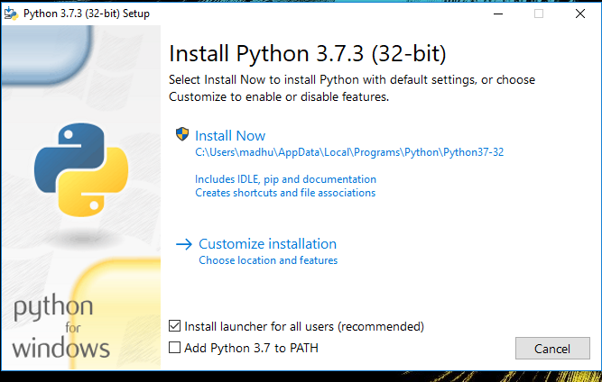

1. Select **Customize installation**.

Choose the optional features by checking the following check boxes:

1. Documentation
2. pip
3. tcl/tk and IDLE (to install tkinter and IDLE)
4. Python test suite (to install the standard library test suite of Python)
5. Install the global launcher for `.py` files. This makes it easier to start Python
6. Install for all users.

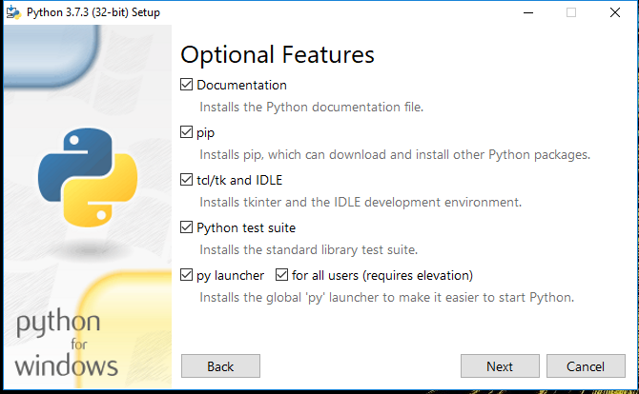

Click Next.

1. This takes you to Advanced Options available while installing Python. Here, select the Install for all users and Add Python to environment variables check boxes.

Optionally, you can select the Associate files with Python, Create shortcuts for installed applications and other advanced options. Make note of the python installation directory displayed in this step. You would need it for the next step.

After selecting the Advanced options, click Install to start installation.

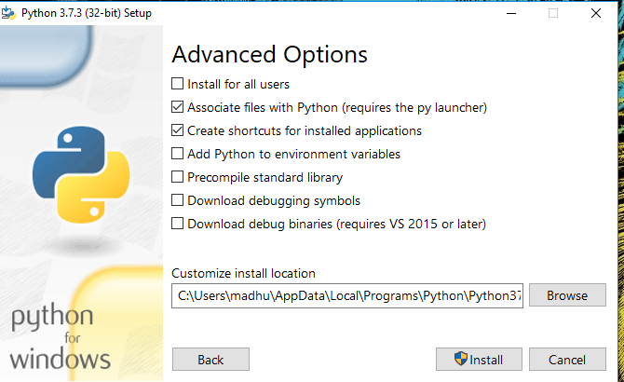

1. Once the installation is over, you will see a Python Setup Successful window.

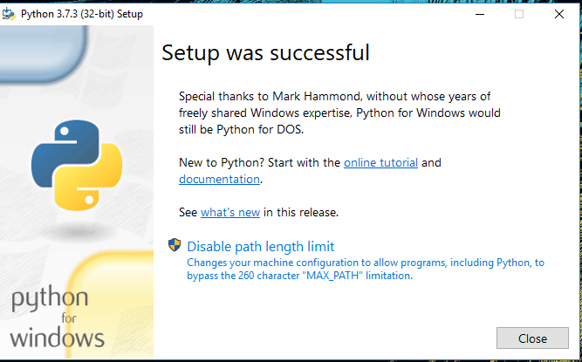

**Step 3:** Add Python to environmental variables

The last (optional) step in the installation process is to add Python Path to the System Environment variables. This step is done to access Python through the command line. In case you have added Python to environment variables while setting the Advanced options during the installation procedure, you can avoid this step. Else, this step is done manually as follows.

In the Start menu, search for “advanced system settings”. Select “View advanced system settings”. In the “System Properties” window, click on the “Advanced” tab and then click on the “Environment Variables” button.

Locate the Python installation directory on your system. If you followed the steps exactly as above, python will be installed in below locations:

* C:\Program Files (x86)\Python37-32: for 32-bit installation
* C:\Program Files\Python37-32: for 64-bit installation

The folder name may be different from “Python37-32” if you installed a different version. Look for a folder whose name starts with Python.

Append the following entries to PATH variable as shown below:

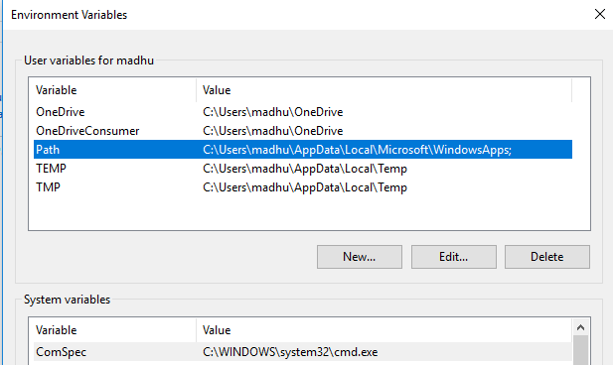

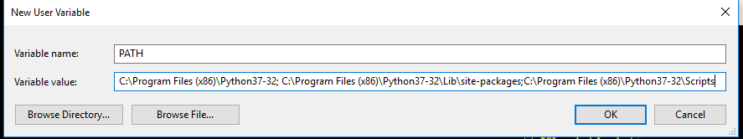

**Step 4:** Verify the Python Installation

You have now successfully installed Python 3.7.3 on Windows 10. You can verify if the Python installation is successful either through the command line or through the IDLE app that gets installed along with the installation. Search for the command prompt and type “python”. You can see that Python 3.7.3 is successfully installed.

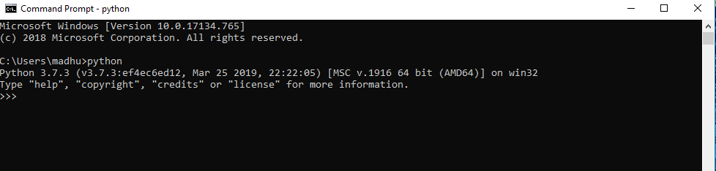

An alternate way to reach python is to search for “Python” in the start menu and clicking on IDLE (Python 3.7 64-bit). You can start coding in Python using the Integrated Development Environment(IDLE).

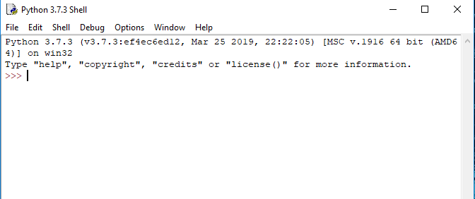

**Uses**

Since 2003, Python has consistently ranked in the top ten most popular programming languages in the TIOBE Programming Community Index where, as of February 2020, it is the third most popular language (behind Java, and C). It was selected Programming Language of the Year in 2007, 2010, and 2018.

* An empirical study found that scripting languages, such as Python, are more productive than conventional languages, such as C and Java, for programming problems involving string manipulation and search in a dictionary, and determined that memory consumption was often "better than Java and not much worse than C or C++".
* Large organizations that use Python include Wikipedia, Google, Yahoo!, CERN, NASA, Facebook, Amazon, Instagram, Spotify and some smaller entities like ILM and ITA. The social news networking site Reddit is written entirely in Python.
* Python can serve as a scripting language for web applications, e.g., via mod_wsgi for the Apache web server. With Web Server Gateway Interface, a standard API has evolved to facilitate these applications. Web frameworks like Django, Pylons, Pyramid, TurboGears, web2py, Tornado, Flask, Bottle and Zope support developers in the design and maintenance of complex applications. Pyjs and IronPython can be used to develop the client-side of Ajax-based applications.
* SQLAlchemy can be used as data mapper to a relational database. Twisted is a framework to program communications between computers, and is used (for example) by Dropbox.
* Libraries such as NumPy, SciPy and Matplotlib allow the effective use of Python in scientific computing, with specialized libraries such as Biopython and Astropy providing domain-specific functionality. SageMath is a mathematical software with a notebook interface programmable in Python: its library covers many aspects of mathematics, including algebra, combinatorics, numerical mathematics, number theory, and calculus.
* Python has been successfully embedded in many software products as a scripting language, including in finite element method software such as Abaqus, 3D parametric modeler like FreeCAD, 3D animation packages such as 3ds Max, Blender, Cinema 4D, Lightwave, Houdini, Maya, modo, MotionBuilder, Softimage, the visual effects compositor Nuke, 2D imaging programs like GIMP, Inkscape, Scribus and Paint Shop Pro, and musical notation programs like scorewriter and capella. GNU Debugger uses Python as a pretty printer to show complex structures such as C++ containers. Esri promotes Python as the best choice for writing scripts in ArcGIS. It has also been used in several video games, and has been adopted as first of the three available programming languages in Google App Engine, the other two being Java and Go.
* Python is commonly used in artificial intelligence projects with the help of libraries like TensorFlow, Keras, Pytorch and Scikit-learn. As a scripting language with modular architecture, simple syntax and rich text processing tools, Python is often used for natural language processing.
* Many operating systems include Python as a standard component. It ships with most Linux distributions, AmigaOS 4, FreeBSD (as a package), NetBSD, OpenBSD (as a package) and macOS and can be used from the command line (terminal). Many Linux distributions use installers written in Python: Ubuntu uses the Ubiquity installer, while Red Hat Linux and Fedora use the Anaconda installer. Gentoo Linux uses Python in its package management system, Portage.
* Python is used extensively in the information security industry, including in exploit development.
* Most of the Sugar software for the One Laptop per Child XO, now developed at Sugar Labs, is written in Python. The Raspberry Pi single-board computer project has adopted Python as its main user-programming language.
* Due to Python's user-friendly conventions and easy-to-understand language, it is commonly used as an intro language into computing sciences with students. This allows students to easily learn computing theories and concepts and then apply them to other programming languages.

**CHAPTER-5**

**IMPLEMENTATION**

**MODULES:**

* User
* Admin
* Data preprocess
* Model Execution

**MODULES DESCRIPTION:**

**User:**

The User can register the first. While registering he required a valid user email and mobile for further communications. Once the user register then admin can activate the customer. Once admin activated the User then user can login into our system. The dataset collected from US Bureau of Transport is not directly processed. Before process we need to clean the data. Once clean the data then user can test the departure delay performance based on selected models. The user can see the results in the browser. The all error scores displayed and graphical representation can be displayed.

**Admin:**

Admin can login with his credentials. Once he login he can activate the users. The activated user only login in our applications. We have studied from various sources to find out which parameters will be most appropriate to predict the departure and arrival delays. After several searches we conclude the dataset parameters are Day, Departure Delay, Airline, Flight Number, Destination Airport, Origin Airport, Day of Week, Taxi out. So this data we consider for further process.

**Data Preprocess:**

The admin provided data has been stored in the sqlite database. To process our methodology we need to perform data cleaning process. By using pandas data frame we can fill the missing values with its mean type. Once data cleaned the data will be displayed on the browser.

**Model Execution**

Machine learning models such as Logistic Regression, Decision Tree Regression, Bayesian Ridge, Random Forest Regression and Gradient Boosting Regression we predict result. The MSE is appropriate for our regression problems since it is differentiable, contributing to the stability of the algorithms. It also heavily punishes the bigger errors over smaller errors. MAE is a risk providing metric which tells the expected value of the absolute error loss. Explained Variance Score proportion with which our machine learning model explains the scattering of the dataset is measured by this technique. R2 Score Goodness of fit is indicated by this metric and hence it measures the probability of the model to predict unknown samples, through the proportion of explained variance. The best score can be 1.0 and the score can also be negative.

**CHAPTER-6**

**SYSTEM STUDY & TESTING**

**FEASIBILITY STUDY**

The feasibility of the project is analyzed in this phase and business proposal is put forth with a very general plan for the project and some cost estimates. During system analysis the feasibility study of the proposed system is to be carried out. This is to ensure that the proposed system is not a burden to the company. For feasibility analysis, some understanding of the major requirements for the system is essential.

**Three key considerations involved in the feasibility analysis are,**

* **ECONOMICAL FEASIBILITY**
* **TECHNICAL FEASIBILITY**
* **SOCIAL FEASIBILITY**

**ECONOMICAL FEASIBILITY**

This study is carried out to check the economic impact that the system will have on the organization. The amount of fund that the company can pour into the research and development of the system is limited. The expenditures must be justified. Thus the developed system as well within the budget and this was achieved because most of the technologies used are freely available. Only the customized products had to be purchased.

### TECHNICAL FEASIBILITY

This study is carried out to check the technical feasibility, that is, the technical requirements of the system. Any system developed must not have a high demand on the available technical resources. This will lead to high demands on the available technical resources. This will lead to high demands being placed on the client. The developed system must have a modest requirement, as only minimal or null changes are required for implementing this system.

**SOCIAL FEASIBILITY**

The aspect of study is to check the level of acceptance of the system by the user. This includes the process of training the user to use the system efficiently. The user must not feel threatened by the system, instead must accept it as a necessity. The level of acceptance by the users solely depends on the methods that are employed to educate the user about the system and to make him familiar with it. His level of confidence must be raised so that he is also able to make some constructive criticism, which is welcomed, as he is the final user of the system.

**SYSTEM TEST**

The purpose of testing is to discover errors. Testing is the process of trying to discover every conceivable fault or weakness in a work product. It provides a way to check the functionality of components, sub assemblies, assemblies and/or a finished product It is the process of exercising software with the intent of ensuring that the Software system meets its requirements and user expectations and does not fail in an unacceptable manner. There are various types of test. Each test type addresses a specific testing requirement.

### TYPES OF TESTS

**Unit testing**

Unit testing involves the design of test cases that validate that the internal program logic is functioning properly, and that program inputs produce valid outputs. All decision branches and internal code flow should be validated. It is the testing of individual software units of the application .it is done after the completion of an individual unit before integration. This is a structural testing, that relies on knowledge of its construction and is invasive. Unit tests perform basic tests at component level and test a specific business process, application, and/or system configuration. Unit tests ensure that each unique path of a business process performs accurately to the documented specifications and contains clearly defined inputs and expected results.

**Integration testing**

Integration tests are designed to test integrated software components to determine if they actually run as one program. Testing is event driven and is more concerned with the basic outcome of screens or fields. Integration tests demonstrate that although the components were individually satisfaction, as shown by successfully unit testing, the combination of components is correct and consistent. Integration testing is specifically aimed at exposing the problems that arise from the combination of components.

**Functional test**

Functional tests provide systematic demonstrations that functions tested are available as specified by the business and technical requirements, system documentation, and user manuals.

Functional testing is centered on the following items:

Valid Input : identified classes of valid input must be accepted.

Invalid Input : identified classes of invalid input must be rejected.

Functions : identified functions must be exercised.

Output : identified classes of application outputs must be exercised.

Systems/Procedures : interfacing systems or procedures must be invoked.

Organization and preparation of functional tests is focused on requirements, key functions, or special test cases. In addition, systematic coverage pertaining to identify Business process flows; data fields, predefined processes, and successive processes must be considered for testing. Before functional testing is complete, additional tests are identified and the effective value of current tests is determined.

**System Test**

System testing ensures that the entire integrated software system meets requirements. It tests a configuration to ensure known and predictable results. An example of system testing is the configuration oriented system integration test. System testing is based on process descriptions and flows, emphasizing pre-driven process links and integration points.

**White Box Testing**

White Box Testing is a testing in which in which the software tester has knowledge of the inner workings, structure and language of the software, or at least its purpose. It is purpose. It is used to test areas that cannot be reached from a black box level.

**Black Box Testing**

Black Box Testing is testing the software without any knowledge of the inner workings, structure or language of the module being tested. Black box tests, as most other kinds of tests, must be written from a definitive source document, such as specification or requirements document, such as specification or requirements document. It is a testing in which the software under test is treated, as a black box .you cannot “see” into it. The test provides inputs and responds to outputs without considering how the software works.

**Unit Testing**

Unit testing is usually conducted as part of a combined code and unit test phase of the software lifecycle, although it is not uncommon for coding and unit testing to be conducted as two distinct phases.

**Test strategy and approach**

Field testing will be performed manually and functional tests will be written in detail.

**Test objectives**

* All field entries must work properly.
* Pages must be activated from the identified link.
* The entry screen, messages and responses must not be delayed.

**Features to be tested**

* Verify that the entries are of the correct format
* No duplicate entries should be allowed
* All links should take the user to the correct page.

# Integration Testing

Software integration testing is the incremental integration testing of two or more integrated software components on a single platform to produce failures caused by interface defects.

The task of the integration test is to check that components or software applications, e.g. components in a software system or – one step up – software applications at the company level – interact without error.

**Test Results:** All the test cases mentioned above passed successfully. No defects encountered.

**Acceptance Testing**

User Acceptance Testing is a critical phase of any project and requires significant participation by the end user. It also ensures that the system meets the functional requirements.

**Test Results:** All the test cases mentioned above passed successfully. No defects encountered.

**CHAPTER-7**

**SCREEN SHOTS**

**Home page**

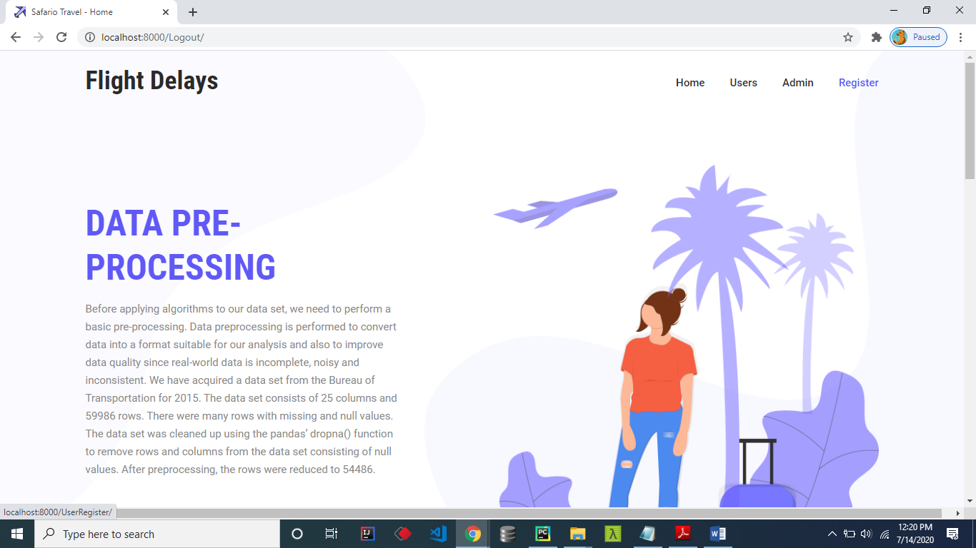

**Register Form**

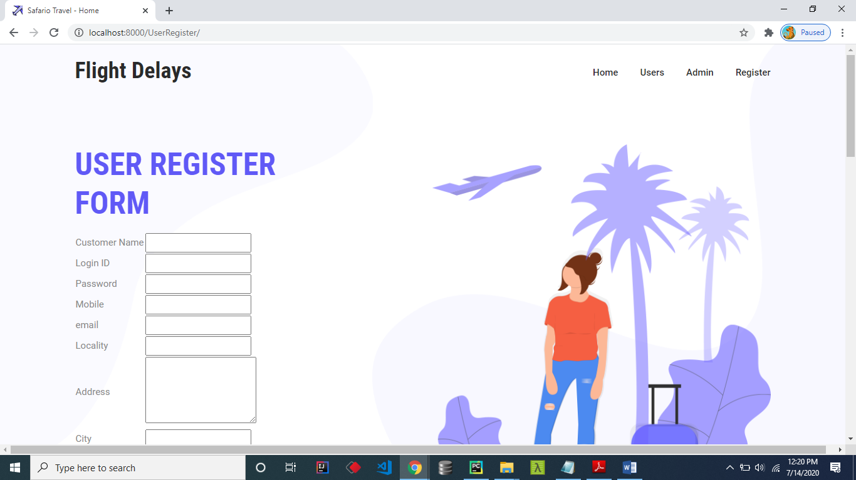

**User Login Form:**

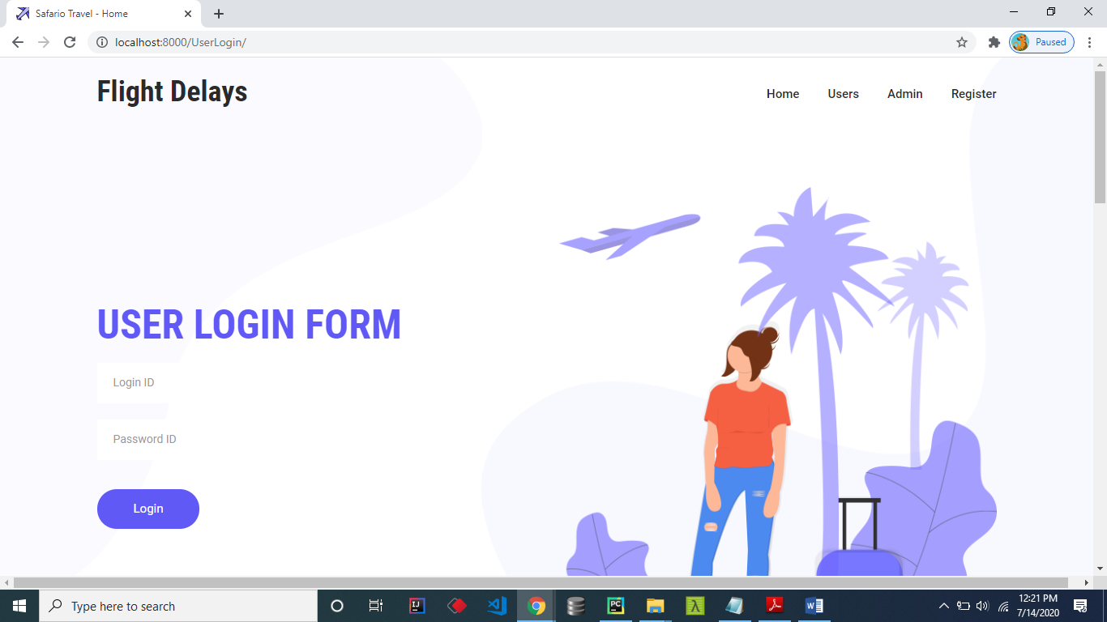

**User Home Page:**

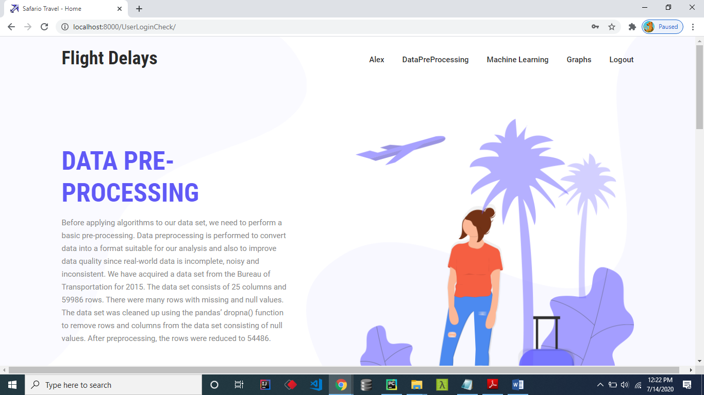

**Preprocessed Data:**

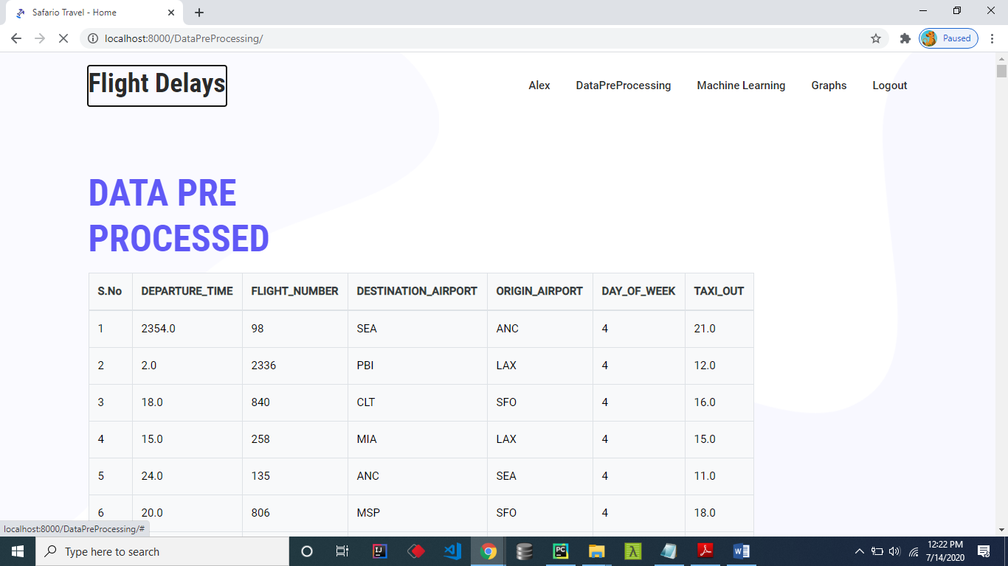

**Algorithm codes:**

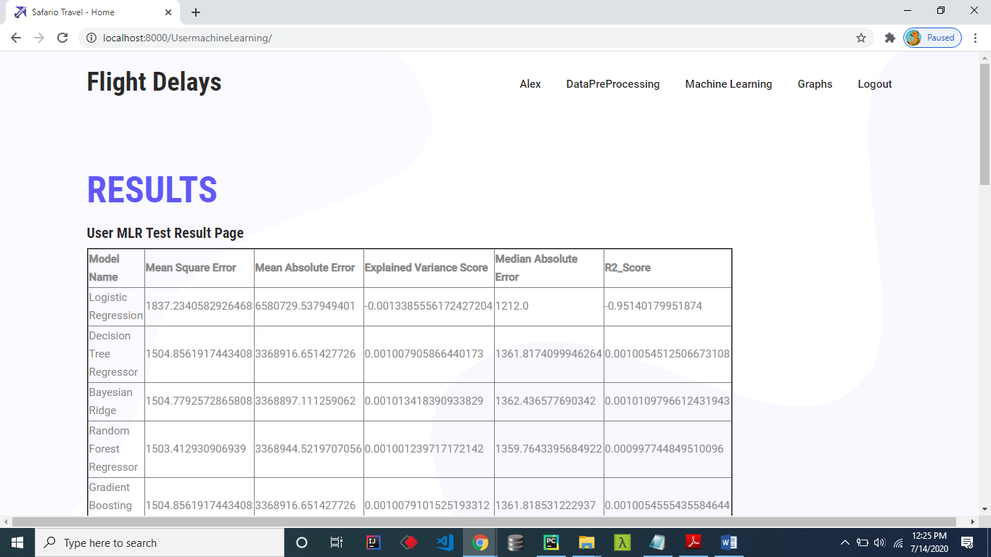

**User Side graphs**

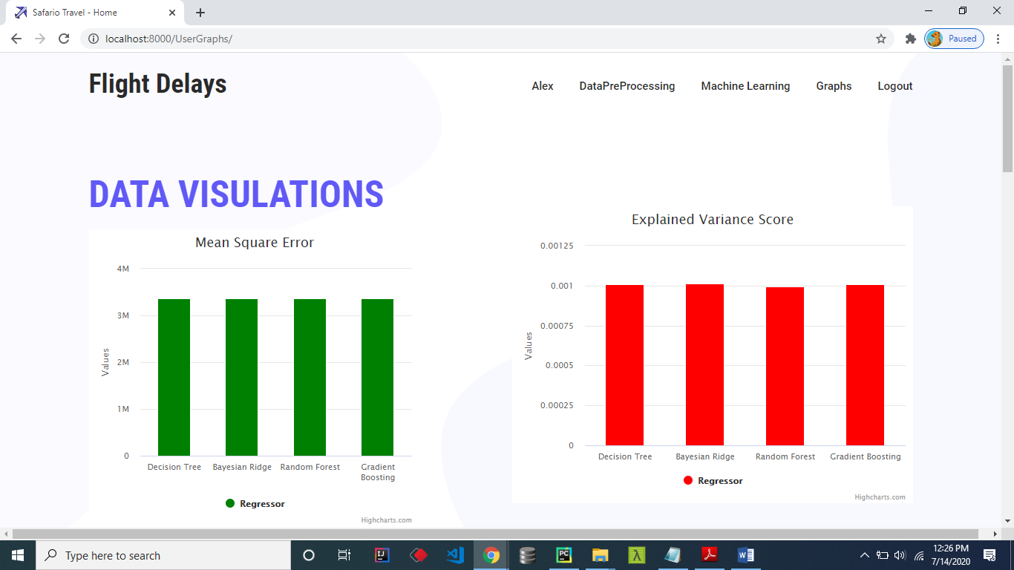

**Graph:**

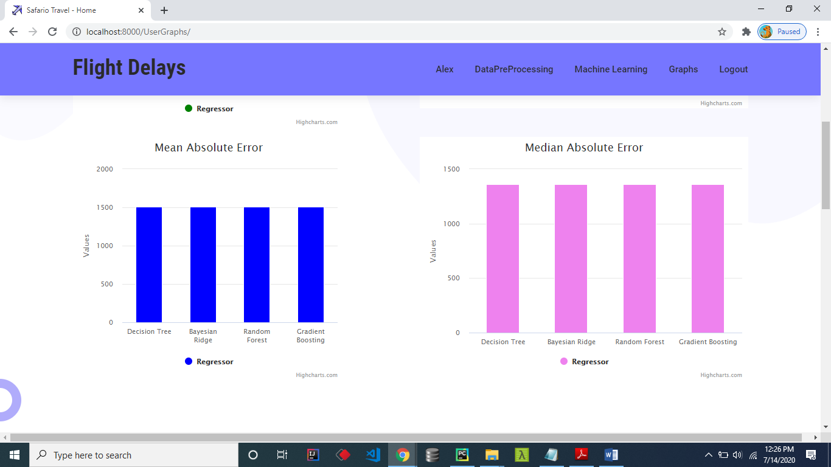

**Admin Login page:**

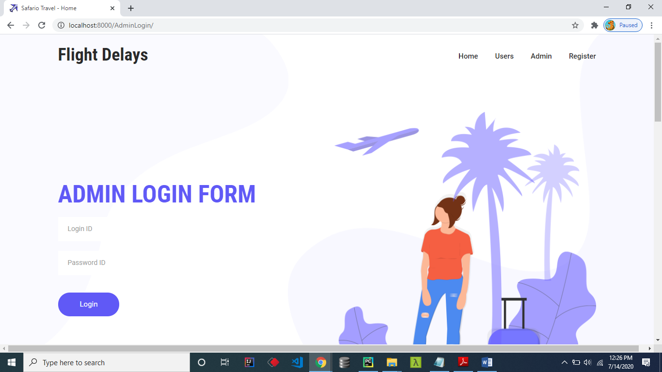

**Admin home Page:**

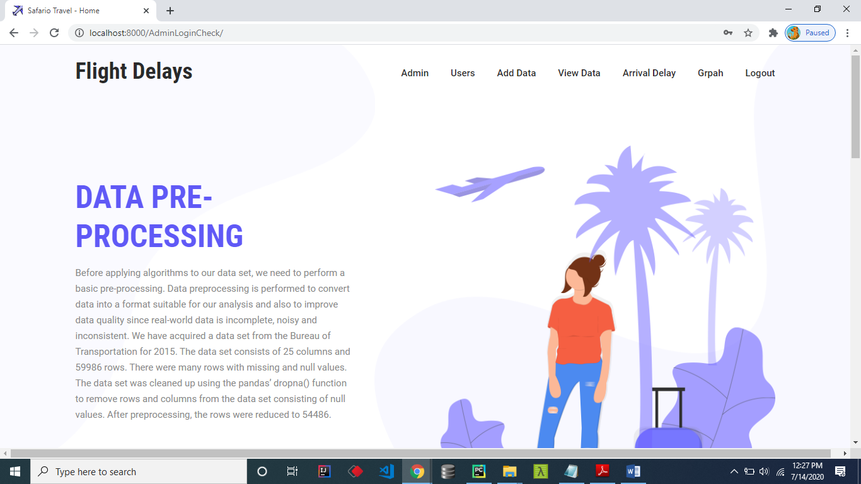

**Admin Adding Data**

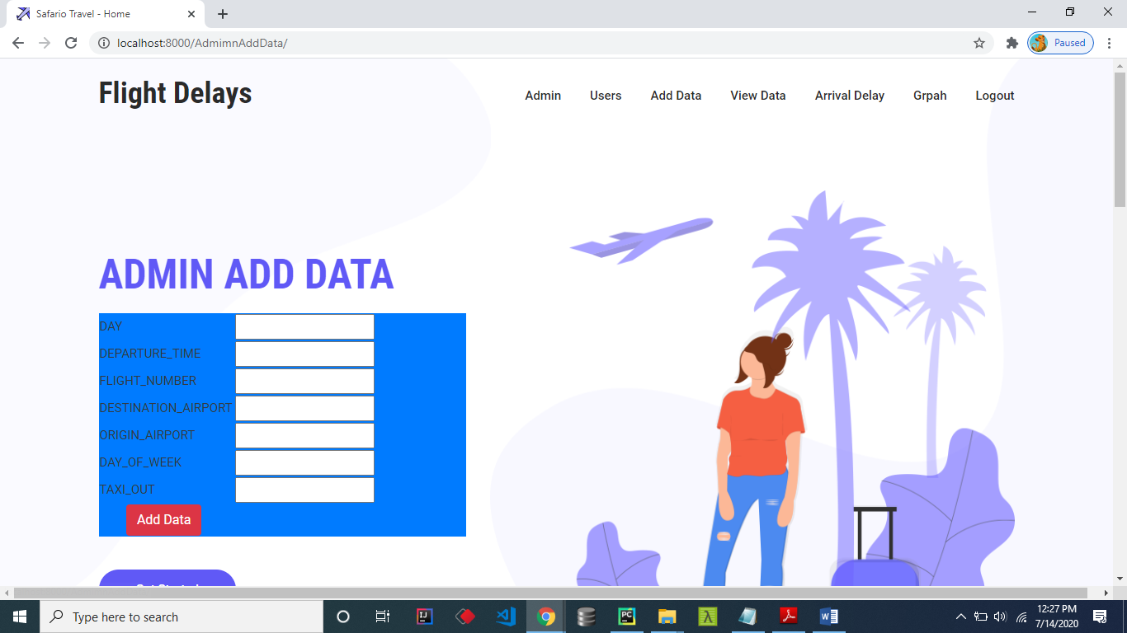

**Admin ViewData**

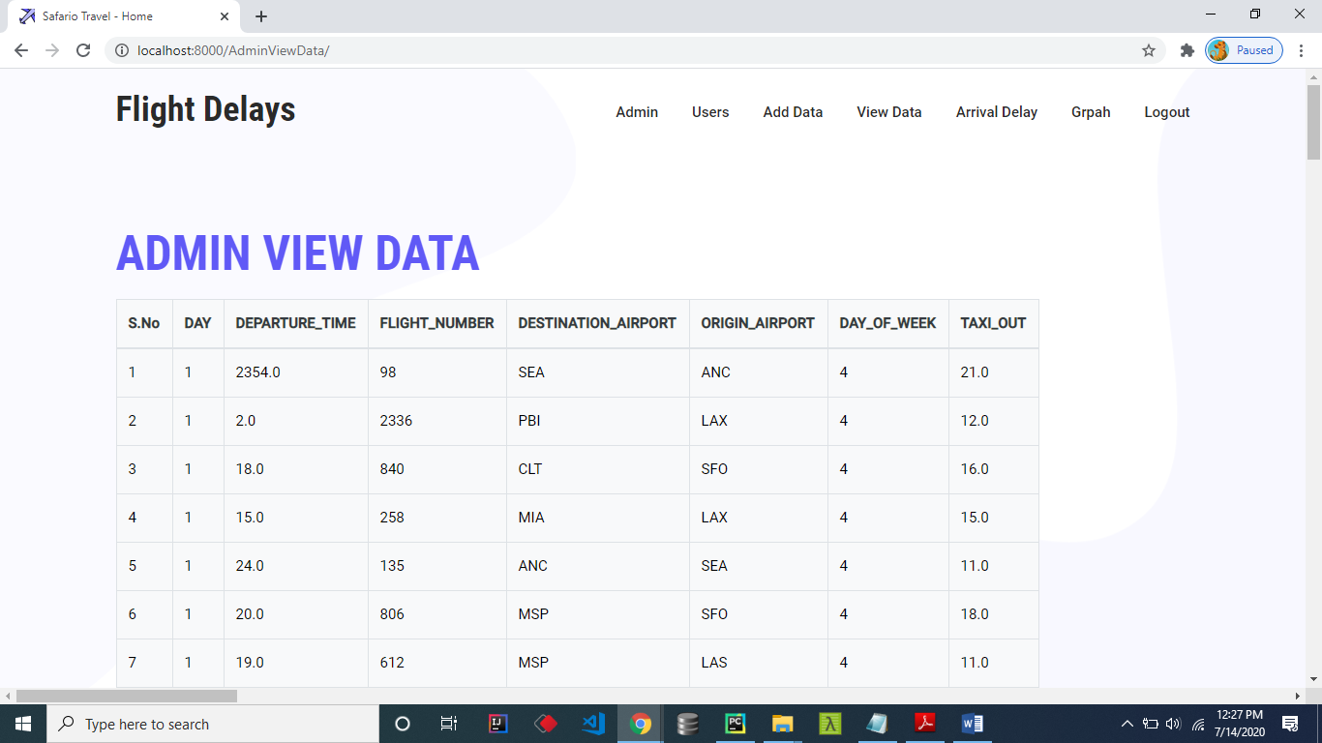

**Admin View Results**

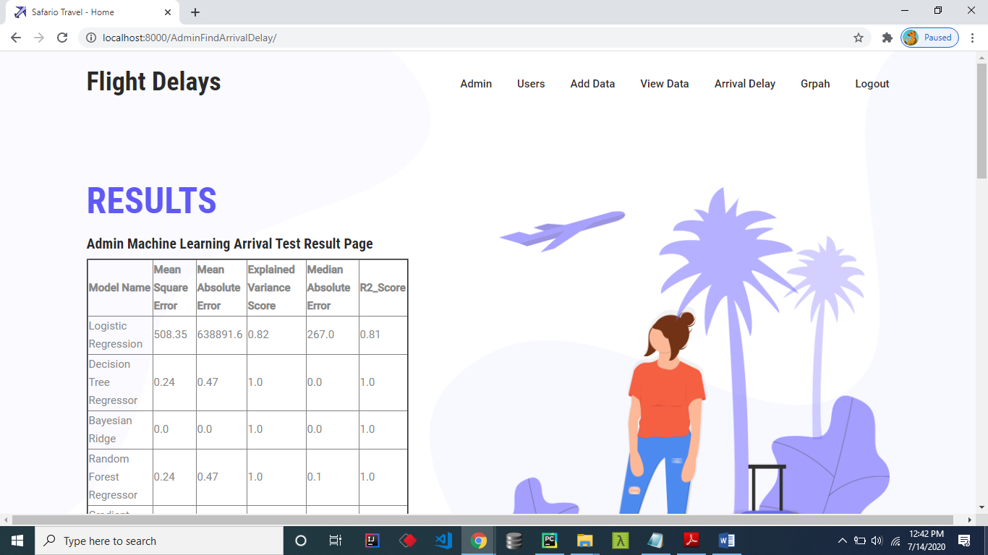

**Arrival Graph**

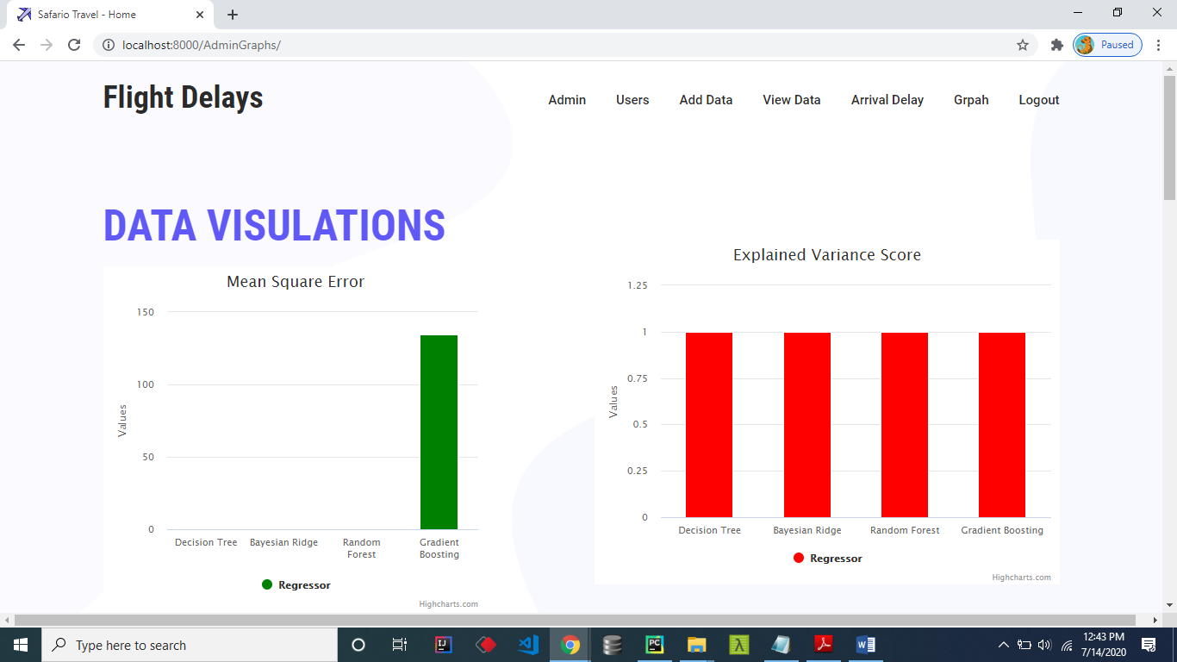

**Arrival Graph:**

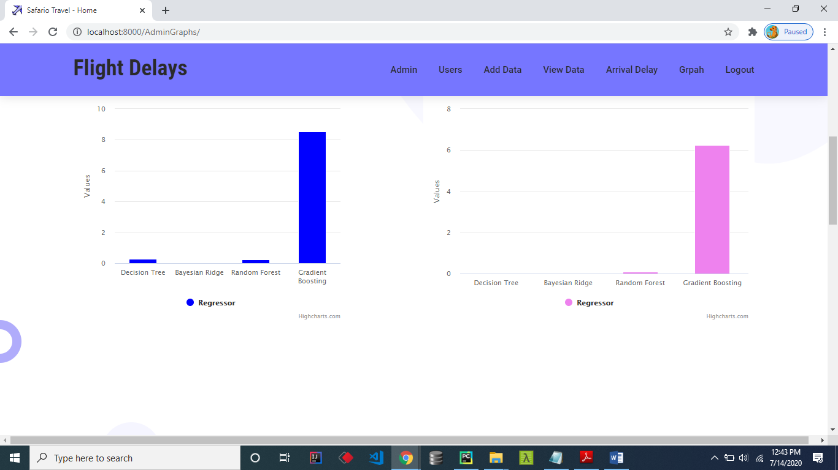

**Server Side results**

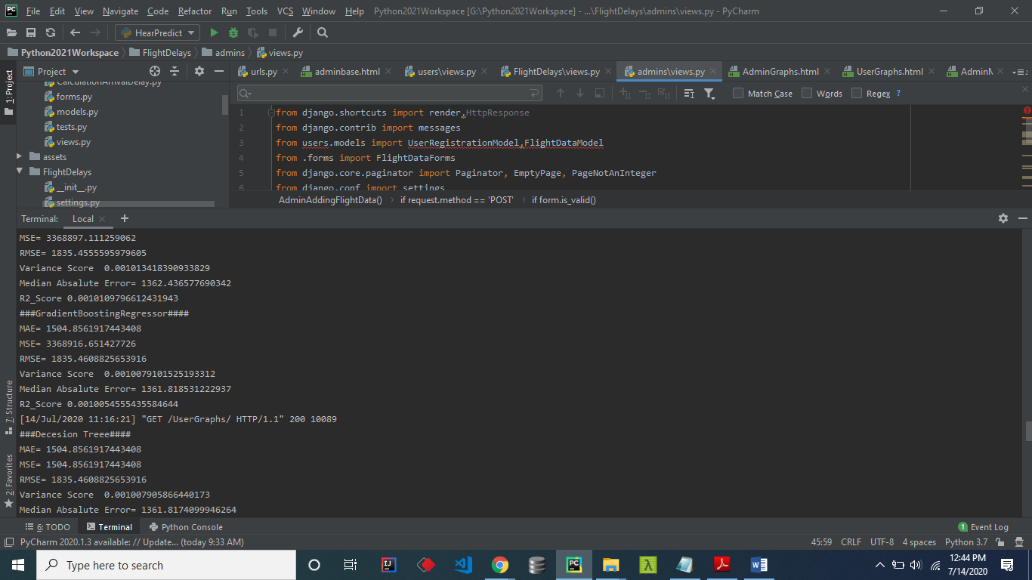

**CHAPTER-8**

**CONCLUSION**

Machine learning algorithms were applied progressively and successively to predict flight arrival & delay. We built five models out of this. We saw for each evaluation metric considered the values of the models and compared them. We found out that: - In Departure Delay, Random Forest Regressor was observed as the best model with Mean Squared Error 2261.8 and Mean Absolute Error 24.1, which are the minimum value found in these respective metrics. In Arrival Delay, Random Forest Regressor was the best model observed with Mean Squared Error 3019.3 and Mean Absolute Error 30.8, which are the minimum value found in these respective metrics. In the rest of the metrics, the value of the error of Random Forest Regressor although is not minimum but still gives a low value comparatively. In maximum metrics, we found out that Random Forest Regressor gives us the best value and thus should be the model selected.

**FURTHER ENHANCEMENT**

The future scope of this paper can include the application of more advanced, modern and innovative preprocessing techniques, automated hybrid learning and sampling algorithms, and deep learning models adjusted to achieve better performance. To evolve a predictive model, additional variables can be introduced. e.g., a model where meteorological statistics are utilized in developing error-free models for flight delays. In this paper we used data from the US only, therefore in future, the model can be trained with data from other countries as well. With the use of models that are complex and hybrid of many other models provided with appropriate processing power and with the use of larger detailed datasets, more accurate predictive models can be developed. Additionally, the model can be configured for other airports to predict their flight delays as well and for that data from these airports would be required to incorporate into this research.

.

**REFERENCES**

[1] N. G. Rupp, "Further Investigation into the Causes of Flight Delays," in Department of Economics, East Carolina University, 2007.

[2] "Bureau of Transportation Statistics (BTS) Databases and Statistics," [Online]. Available: <http://www.transtats.bts.gov>.

[3] "Airports Council International, World Airport Traffic Report," 2015,2016.

[4] E. Cinar, F. Aybek, A. Caycar, C. Cetek, "Capacity and delay analysis for airport manoeuvring areas using simulation," Aircraft Engineering and Aerospace Technology, vol. 86, no. No. 1,pp. 43-55, 2013.

[5] Navoneel, et al., Chakrabarty, "Flight Arrival Delay Prediction Using Gradient Boosting Classifier," in Emerging Technologies in Data Mining and Information Security, Singapore, 2019.

[6] Y. J. Kim, S. Briceno, D. Mavris, Sun Choi, "Prediction of weatherinduced airline delays based on machine learning algorithms," in 35th Digital Avionics Systems Conference (DASC), 2016.

[7] W.-d. Cao. a. X.-y. Lin, "Flight turnaround time analysis and delay prediction based on Bayesian Network," Computer Engineering and Design, vol. 5, pp. 1770-1772, 2011.

[8] J. J. Robollo, Hamsa, Balakrishnan, "Characterization and Prediction of Air Traffic Delays".

[9] S. Sharma, H. Sangoi, R. Raut, V. C. Kotak, S. Oza, "Flight Delay Prediction System Using Weighted Multiple Linear Regression," International Journal of Engineering and Computer Science, vol. 4, no. 4, pp. 11668 - 11677, April 2015.

[10] A. M. Kalliguddi, Area K., Leboulluec, "Predictive Modelling of Aircraft Flight Delay," Universal Journal of Management, pp. 485 - 491, 2017.

[11] Noriko, Etani, "Development of a predictive model for on-time arrival fight of airliner by discovering correlation between fight and weather data," 2019.

[12] [Online]. Available: <https://towardsdatascience.com/metrics-toevaluate-your-machine-learning-algorithm-f10ba6e38234>.

[13] C. J. Willmott, Matsuura, "Advantages of the mean absolute error (MAE) over the root mean square(RMSE) in assessing average model performance," Climate Research, vol. 30, no. 1, pp. 79 - 82, 2005.

[14] [Online]. Available: http://scikitlearn.org/stable/modules/classes.html?source=post_page-- ---f10ba6e38234----------------------#sklearn-metrics-metrics.